PSSI Science Project Reporting Template

️ | The PSSI Implementation Team is compiling a technical report to demonstrate the important research and advancements made by the Science Branch through the PSSI funding. The technical report will include a 3-4 page summary (including graphics and figures) for each project to show their key results and findings. Please fill in the following fields and sections for your project to be included in the report. Feel free to include and draw from any reports or presentations previously created through your research.  A plain language science bulletin will also be created to follow up on last year’s “DFO Pacific Region Science Bulletin, 2024. New research and monitoring for Pacific salmon and their ecosystems.” While the first bulletin introduced project backgrounds, methods, and timelines, this new bulletin will highlight the projects’ results, key findings, and conclusions with links to reports and data available. The bulletin will include a 1-2 page summary for each project gleaned from the content entered below.  ️ Completed forms are due January 7, 2026.  *Please include or send separately any graphics or pictures (with photo credits) that will help promote the projects.

PART 1: PROJECT METADATA

General Project Information
Project ID (number) | Project Title
2410 | Improved decision making for salmon by understanding the threats of freshwater Aquatic Invasive Species both now and in the future
Project Leads | Collaborations and External Partners
Thomas Therriault | Province of British Columbia, Pacific Salmon Commission
Location (if applicable) | Province of British Columbia, Pacific Salmon Commission
Click or tap here to enter text. | Province of British Columbia, Pacific Salmon Commission

Geographic and Stock Information
Salmon species (if applicable) | Waterbodies (if applicable)
All | All; Freshwater Ecoregions of the World
Life history phases (if applicable) | Region
All | Pacific Region
Stock (if applicable) | Population (if applicable)
All | Click or tap here to enter text.
Conservation Unit (if applicable)
All

🧰 PART 2: PROJECT METRICS

Project Outputs
Include any anticipated outputs denoted as (in progress). Please include links to any outputs available online so they can be referenced in the report.
List scientific publications and technical reports (with links)
Wilcox, M.A., Johnson, D., Dyke, K., Gunsch, D., Lyons, D.A., DiBacco, C., and Therriault, T.W. 2025. Identifying higher risk invaders to the Columbia Glaciated Freshwater Ecoregion using a new screening tool: the Non-Indigenous Species Screening Tool (NISST). Management of Biological Invasions 16(1): 187-210. https://doi.org/10.3391/mbi.2025.16.1.12

Wilcox, M.A., Johnson, D.L., Dyke, K.D., Gunsch, D., Danielewicz, K., DiBacco, C., Lyons, D.A., and Therriault, T.W. 2026. Identifying higher risk invaders to British Columbia’s five freshwater ecoregions and three Canadian marine ecoregions using a new screening-level risk assessment tool: NISST (Non-Indigenous Species Screening Tool), June 2024. DFO Can. Sci. Advis. Sec. Res. Doc. 2026/nnn. iv + xx p. (in press)

List datasets generated (with links)
Two separate databases used in this project are in development – one contains all the supporting information on each of the species that was assessed using NISST and the other contains background information on the assessment areas (ecoregions) in support of NISST assessments. These will be useful for those looking to apply NISST on similar species in other areas and by managers that likely will require more detailed information for specific management actions.
Describe dataset locations and data management systems
Data used in this project currently is only available internally and we are exploring options to make this data publicly accessible (consistent with national data standards).
List code, programs, or other software created (with links)
NISST user guide and R code available in Wilcox et al. 2025 (above) https://github.com/MarkAlanWilcox/Non-Indigenous-Species-Screening-Tool-NISST
List communication or social media products
Click or tap here to enter text.
List and describe field work completed
Click or tap here to enter text.
List and describe samples collected/analyzed (number of samples)
Click or tap here to enter text.
List and describe large capital assets or equipment acquired
Click or tap here to enter text.

PART 3: WRITTEN CONTENT

Highlights
Please summarize in 2-3 bullets:
- The main idea of the project
- Key findings
- Implications of these findings for salmon and decision-makers
- For a more technical audience, but still as plain language as possible
This project has prioritized the risk of 515 Aquatic Invasive Species across multiple taxa (primarily fish, invertebrates and plants) for five freshwater ecoregions in the Pacific Region.

Several high risk AIS were identified within each taxonomic group and ecoregion that could negatively impact salmon stocks throughout the Pacific Region.

Managers and other decision makers need to explicitly consider the many threats posed by AIS in management and recovery plans for all salmon stocks in Pacific Region, recognizing these threats will not be uniform.

Background
Please provide 1-2 paragraphs to summarize
- The relevant biological, environmental, and/or management context
- What knowledge gap or demand were you trying to fill?
- Collaboration and partner relationships
Climate change and Aquatic Invasive Species (AIS) are leading threats to biodiversity globally. In British Columbia (BC), many salmon stocks have been assessed as at-risk by COSEWIC (Committee on the Status of Endangered Wildlife in Canada), but while climate change has been increasingly considered in salmon management and policy, the threat posed by AIS has largely been ignored. Further, stressors like increasing global temperatures are out of the control of regional management while AIS can be managed locally given resources and interest. By targeting those AIS most likely to have the biggest impact on salmon survival or productivity, we can improve salmon recovery by reducing the stress that these invasive species cause. AIS impacts on salmon are well documented in the US Pacific Northwest where, for example, invasive Walleye consume up to 2 million smolts a year in the Columbia River (Sanderson et al. 2009). The expansion of Northern Pike in Alaska has led to the decline of salmon productivity in some regions and all five salmon species have been classified as highly vulnerable to pike invasion in at least part of their Alaskan range (Jalbert et al. 2021). Habitat alteration can also impact salmon: Schwoerer et al. (2019) estimated the potential for $159 million annual damage to the Alaskan Sockeye salmon industry from one invasive plant species, Elodea. However, the extent and relative impact of freshwater AIS threats to salmon habitat and productivity have yet to be assessed in the Pacific Region (BC/Yukon). Here we will fill this gap by applying a novel screening level risk assessment tool to prioritize species (fish, invertebrates and plants) that have already invaded BC/Yukon, are nearby or in a known vector/pathway. By using freshwater ecoregions we are able to characterize the general risk of these species both now and in the future at a scale suitable to many management and policy venues.

Information generated via this project will have tremendous utility to those managers, First Nations, and stakeholders being impacted by AIS both now and in the future. As the freshwater assessments wrap up our intent is to reach out to various groups to convey the risk of the many species assessed here and to work with them on management or control plans based on their needs.

️ Methods and Findings
Please insert a few paragraphs to summarize:
- Main methods used
- Products and tools produced
- Advancements in methodology, technology, and application
- Advancements in communication and knowledge transfer
- Key results and information generated
The Non-Indigenous Species Screening Tool (NISST, Wilcox et al. 2025), was developed in collaboration with this PSSI project to fill gaps and address common limitations in previous tools for screening potentially invasive species. It is organized into three separate modules examining steps in the invasion process combined with both ecological and socioeconomic impacts. This tool provides a semiquantitative valuation of risk which explicitly incorporates uncertainty into the score (using a novel Monte Carlo method) and recognizing the increasing importance of considering climate change when assessing invasion risk, this tool also incorporates a modifier for this. From the global species pool we identified >3200 species (including fish, invertebrates and plants) that could become AIS in the Pacific Region and potentially impact salmon. From this master list, we identified 515 to be screened using NISST; with most having some history of invasiveness, being associated with a known invasion vector (e.g., organisms in trade, aquaculture, shipping, etc.), and/or having some climate match to the five freshwater ecoregions that have boundaries within the Pacific Region (British Columbia and Yukon) (Figure 1). This included 245 fish, 83 invertebrates, and 180 plants. This project will produce a ranked list of priority AIS by ecoregion, including arrows to indicate the change in risk under a future climate and a measure of uncertainty using error bars, for both species that have already invaded or have yet to invade. Further, it is possible to produce bi-plots showing the relative contribution of Invasion Potential vs. Ecological Impacts or Socioeconomic Impacts both now and in the future.

The resulting ranked list of AIS by freshwater ecoregion showing taxonomic identity of the invader (fish, invertebrate or plant), its invasion status (present vs not yet detected), the effect of climate change and uncertainty. Additional project data will identify key vectors and pathways (i.e., recreational boating, natural dispersal, organisms in trade, etc.), and AIS-specific impacts to freshwater ecosystems and salmon stocks specifically. The identification of higher risk AIS is essential to refine other PSSI-related assessments of the multiple, often interacting threats to various Pacific salmon stocks and can be used in management plans, recovery assessments, or policy documents. For example, such information can be used to refine estimates of salmon mortality, recovery or productivity thus improving fisheries management advice for salmon. Further, the ranked list of AIS generated through these assessments will inform AIS monitoring and early detection programs both within DFO (AIS NCP), the Province of British Columbia (BC MOE) and the Yukon. Finally, higher risk species can be considered in future amendments to the AIS Regulation in the Fisheries Act and vectors and pathways common among higher risk AIS can be prioritized for policy and regulatory action.

To highlight key NISST outputs we include here working examples of the modular bi-plot outputs (Figure 2) and total risk scores (Figure 3) for some of the higher risk and lower risk fish species assessed for the Alaska and Canada Pacific Coastal ecoregion (FEOW 103 in Figure 1). Please note that there were 245 fish AIS to be assessed with NISST so the final products are likely to differ and these figures are included to illustrate what can be expected at the end of this project. As expected the range of scores obtained for species that are known to be introduced to this ecoregion and those not yet known were comparable across modules (Figure 2) and total risk scores (Figure 3) using two independent assessors. Further, the inclusion of climate change to the scores for each module typically increased the scores (Figures 2 and 3) although the magnitude varied by species.

Although work is ongoing to finalize the highest risk species for each of BC’s five freshwater ecoregions and specific ranks are subject to change, there are notable differences between northern and southern ecoregions with southern ones (103 and 120) having more AIS present including well known invaders such as brown bullhead (Ameiurus nebulosus), goldfish (Carassius auratus), common carp (Cyprinus carpio), and rosy red minnow (Pimephales promelas). Further, there are higher risk AIS belonging to other taxa such as plants like Brazilian elodea (Egeria densa), purple loosestrife (Lythrum salicaria), curled pondweed (Potamogeton crispus), and invertebrates like Asian clam (Corbicula fluminea) and Chinese mystery snail (Cipangopaludina chinensis). When complete it will be possible to consider risk not only at the ecoregion level but across taxonomic groups and invasion status.

Among some of the highest-ranking fish species, common carp and goldfish are known to be environmental generalists, able to survive in a wide range of habitats. Goldfish (Carassius auratus) in particular are also widely available in the aquarium trade and thus their potential (illegal) release is an ongoing concern (Chan et al. 2019). Their ability to consume plant and animals, including eggs, makes them a potential threat to most aquatic organisms at some life stage, and their feeding activities can cause increased turbidity and disruption of aquatic plants, modifying the habitat (i.e., ecosystem engineers) resulting in both ecological and socioeconomic impacts (e.g., Deacon et al. 1964; Moyle 1976; Richardson et al. 1995; Miller and Beckman, 1996; Egertson and Downing, 2004; Weber and Brown, 2009, Jackson et al., 2010). They also carry an extensive number of diseases and parasites with the potential to impact native fish (e.g. Gilad et al., 2004; Poelen et al., 2014).

Another group of higher risk species include some catfish species. For example, channel catfish (Ictalurus punctatus) can spread rapidly due to a high reproductive rate and wide environmental tolerances (Jones et al., 1978). In the Columbia River they consume large numbers of juvenile salmon (Vigg et al. 1991; Sanderson et al. 2009) and predate on fish such as perch, shad, sunfish, razorback suckers, chubs, and endangered frogs (e.g. Robinette and Knight, 1981; Lentsch et al., 1996; Marsh and Douglas, 1997). Similarly, brown bullhead (Ameiurus nebulosus) negatively impact native fish via predation of eggs and competition with species such as endemic sticklebacks (Gasterosteus spp.) on Vancouver Island (Dextrase and Mandrak 2006), brassy minnows (Hybognathus hankinsoni) in the Fraser River (Nowosad and Taylor, 2013), and cisco, herring and lake trout in other parts of Canada (Scott and Crossman, 1973). In addition, they serve as vectors for finfish diseases such as viral haemorrhagic septicaemia (Faisal et al., 2012).

Perhaps not surprisingly most of the lowest risk species had poor climate match to Pacific Region ecosystems, were not known to be invasive elsewhere or possess traits known to facilitate invasion, and lacked documented ecological and socioeconomic impacts. Although several are expected to benefit from a future climate, in most cases they are still not expected to become problematic. Almost half of these species were aquarium fish (116/245) representing both temperate organisms like weatherfish or tropical ones like danios and many (133/245) are known to be in trade in Canada.

Insights
Please insert a few paragraphs to summarize:
- What this project has added to knowledge about salmon populations, health, or ecosystems.
- How this project informs salmon management:
  - decisions
  - policy guidance
  - trade-offs
  - planning
- Addition of knowledge to understanding:
  - limiting factors/stressors/threats/ pathways of effects/risks
  - biologically significant thresholds
  - cumulative impacts
- Sources of uncertainty
It has been recognized for some time that AIS are a significant ecosystem stressor, especially in freshwater ecosystems (Sala et al. 2000), but also that ecosystem impacts can be highly context-dependent. This project is the first to comprehensively prioritize AIS for five freshwater ecoregions in Pacific Region both now and under future climate scenarios to improve management and policy decisions by explicitly considering higher risk AIS at multiple levels of decision making. NISST does not specify thresholds for high, medium or low risk species but rather allows flexibility for management to set these to ensure they are fit-for-purpose. For example, different thresholds might be set for different ecoregions depending on external factors such as salmon conservation units.

Salmon management should more explicitly consider the risks of AIS (and likely other stressors) in the development of truly integrated management plans and Species-at-Risk recovery documents. By recognizing the threat posed by AIS managers can prioritize locations where preventing introductions or spread are a priority and can develop early detection programs for the highest risk species. In locations where AIS might already exist preventing spread or mitigating impacts, especially those on at-risk species, could help preserve ecosystem structure and function, including many salmon stocks. Finally, our project identified that several AIS will benefit from climate change and impacts are expected to increase. Accounting for these types of interactions and cumulative effects could improve management and policy outcomes.

Downscaling the ecoregion risk assessments may be necessary for specific waterbodies in BC to improve salmon or ecosystem management decisions and outcomes. The goal of screening level assessments like NISST is that they provide a relatively rapid characterization of risk for relatively similar areas (here ecoregions) but they are not intended to provide a detailed assessment for any specific waterbody/location within the assessment area. Here detailed risk assessments could be undertaken or screening assessments in conjunction with additional information/data could be used.

Finally, it should be recognized that there was considerable data/information gathered for both the species being assessed and the assessment area in this process (see databases in development above). This information can be used in many decision making processes beyond the screening assessments themselves. For example, this information can be used by managers when developing early detection networks, rapid response, control or management plans for specific AIS, or recovery plans for at-risk species or areas being impacted by AIS. Further, this information can serve as a starting point for additional assessments beyond the Pacific Region as critical information will remain the same and can be used for assessment elsewhere in Canada or beyond.

⏩ Next Steps
Please insert 1-2 paragraphs to summarize:
- Remaining knowledge gaps and recommendations for future studies
- How can/should the project findings be operationalized for salmon conservation and management?
AIS are not confined to freshwater ecosystems, given salmon life cycles they are likely to encounter additional high risk AIS in estuarine and marine ecosystems. Work is currently underway to identifying these higher risk AIS (fish, inverts, plants and algae) as well.

This project has identified higher risk AIS using a new screening tool such that results are standardized and can be used to inform potential regulatory amendments to the Aquatic Invasive Species Regulations in the Fisheries Act. A large number of higher risk AIS are not yet known from Pacific Region so listing could facilitate proactive measures to keep these species out or have early detection/surveillance and rapid response plans in place should they arrive.

Identifying and responding to AIS is a shared responsibility so communication products are needed to raise awareness among First Nations, stakeholders, and the public about the risks AIS pose to BC ecosystems, including salmon. This should include where to report suspicious species so the proper management actions can be undertaken (and responses are for AIS and not similar looking native species).

📈 Tables and Figures
Please provide captions and numbering for any tables and figures. Graphics can be copied below or e-mailed separately.
- Include a brief caption with each figure and table in the box below
- Number each table and figure, and include references in the above sections where appropriate.
- 1-3 figures are recommended per project
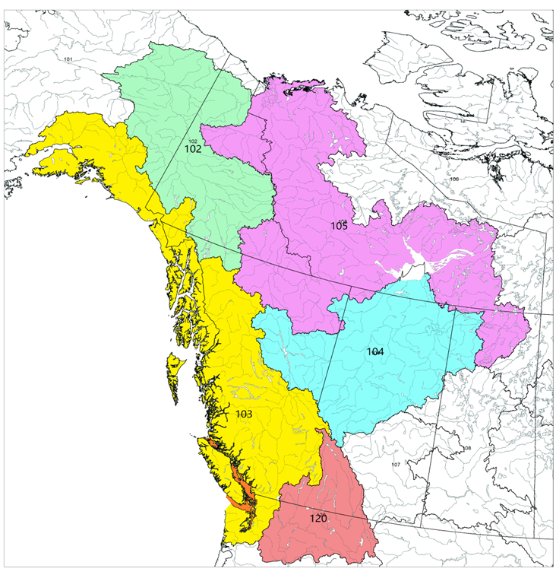

Figure 1. Map of the five freshwater ecoregions of the world (FEOW) that overlap with the Pacific Region. These ecoregions include the Upper Yukon FEOW (102), the Alaska and Canada Pacific Coast FEOW (103), the Upper Mackenzie FEOW (104), the Lower Mackenzie FEOW (105) and the Columbia Glaciated FEOW (120).

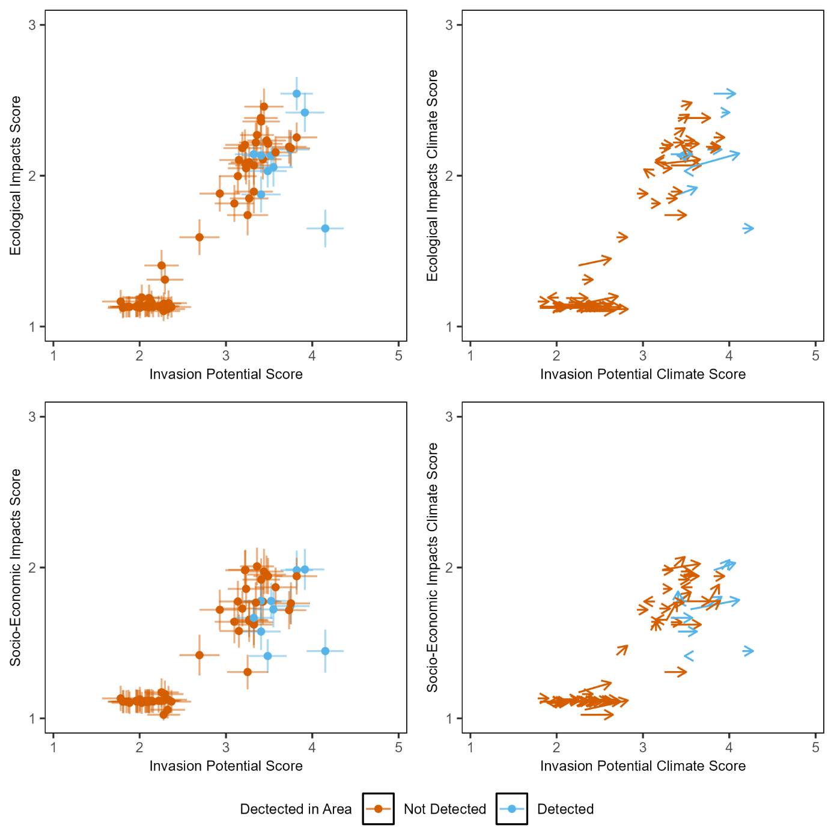

Figure 2. Biplots showing impact (ecological in the top panel and socioeconomic in the bottom panel) plotted against invasion potential for each example fish species screened using NISST for the Alaska and Canada Pacific Coast FEOW (103). Error bars represent the propagated error based on standard deviations from the Monte Carlo simulations. Vector plots showing the change in scores when using the climate modifier questions, where the base of the arrow depicts the unmodified score and the tip of the arrow depicts the climate modified score (Right). The length of the line depicts magnitude and the direction indicates the relative contributions of impacts and invasion potential to the modified scores. This plot is only showing a selection of higher risk and lower risk species – the same as those included in Figure 3. Note the final product will produce a continuum of scores.

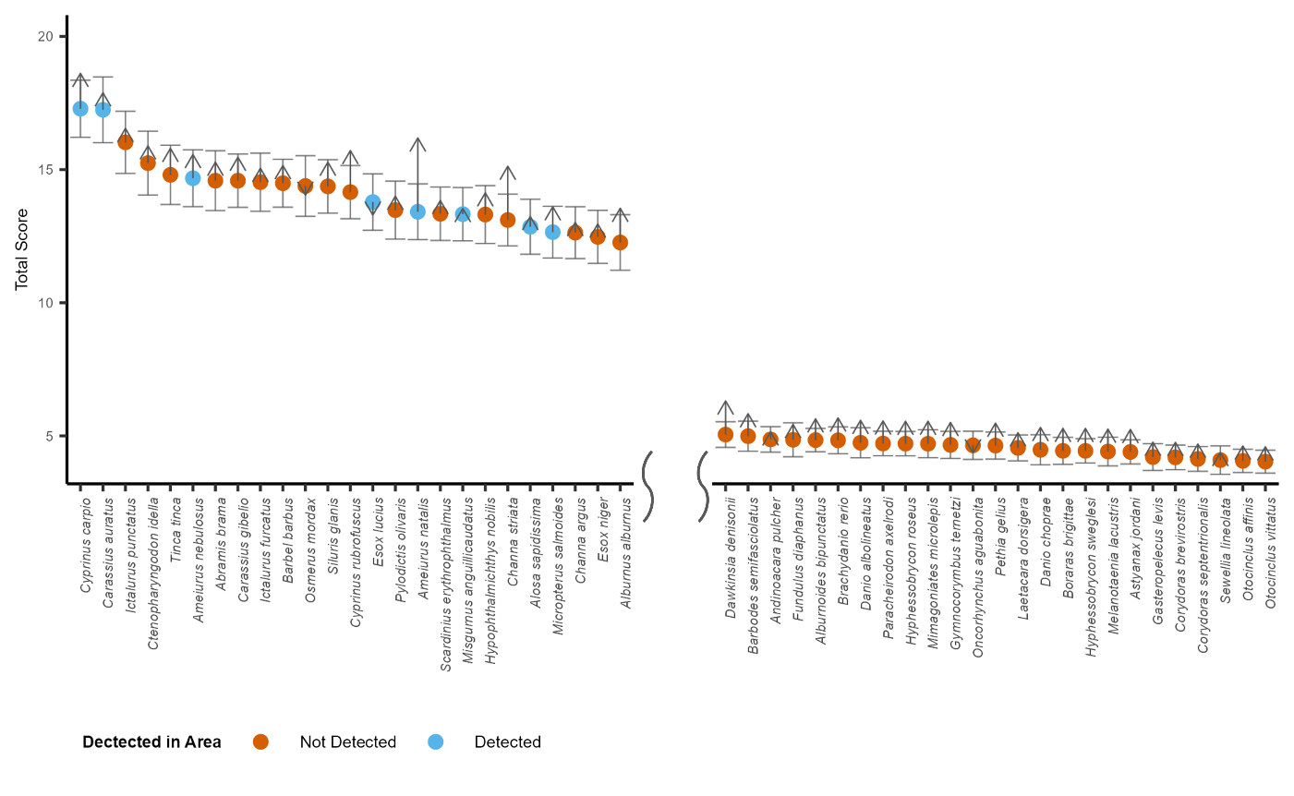

Figure 3: Ranked NISST scores for example fish species for the Alaska and Canada Pacific Coast FEOW (103). A selection of higher risk and lower risk species are shown (the final product will produce a continuum for the full extent of species assessed). Error bars represent propagated error based on standard deviations from the Monte Carlo simulation. Arrows depict the climate modified scores.

📈 References
Include full references for any publications referenced in other sections. Please format references in Harvard style according to Instructions to Authors for the Canadian Journal of Fisheries and Aquatic Sciences, at Canadian Science Publishing.
Chan, F.T., Beatty, S.J., Gilles Jr, A.S., Hill, J.E., Kozic, S., Luo, D., Morgan, D.L., Pavia Jr, R.T., Therriault, T.W., Verreycken, H. and Vilizzi, L., 2019. Leaving the fish bowl: the ornamental trade as a global vector for freshwater fish invasions. Aquatic Ecosystem Health & Management, 22(4), pp.417-439.

Deacon, J.E., Hubbs, C. and Zahuranec, B.J., 1964. Some effects of introduced fishes on the native fish fauna of southern Nevada. Copeia, pp.384-388.

Dextrase, A.J. and Mandrak, N.E., 2006. Impacts of alien invasive species on freshwater fauna at risk in Canada. Biological Invasions, 8(1), pp.13-24.

Egertson, C.J. and Downing, J.A., 2004. Relationship of fish catch and composition to water quality in a suite of agriculturally eutrophic lakes. Canadian Journal of Fisheries and Aquatic Sciences, 61(9), pp.1784-1796.

Faisal, M., Shavalier, M., Kim, R.K., Millard, E.V., Gunn, M.R., Winters, A.D., Schulz, C.A., Eissa, A., Thomas, M.V., Wolgamood, M. and Whelan, G.E., 2012. Spread of the emerging viral hemorrhagic septicemia virus strain, genotype IVb, in Michigan, USA. Viruses, 4(5), pp.734-760.

Gilad, O., Yun, S., Zagmutt-Vergara, F.J., Leutenegger, C.M., Bercovier, H. and Hedrick, R.P., 2004. Concentrations of a Koi herpesvirus (KHV) in tissues of experimentally-infected Cyprinus carpio koi as assessed by real-time TaqMan PCR. Diseases of aquatic organisms, 60, pp.179-187.

Jackson, Z.J., Quist, M.C., Downing, J.A. and Larscheid, J.G., 2010. Common carp (Cyprinus carpio), sport fishes, and water quality: ecological thresholds in agriculturally eutrophic lakes. Lake and Reservoir Management, 26(1), pp.14-22.

Jalbert, C.S., Falke, J.A., López, J.A., Dunker, K.J., Sepulveda, A.J. and Westley, P.A., 2021. Vulnerability of Pacific salmon to invasion of northern pike (Esox lucius) in Southcentral Alaska. PLoS One, 16(7), p.e0254097.

Jones, P.W. and Martin, F.D., 1978. Development of Fishes of the Mid-Atlantic Bight: Acipenseridae Through Ictaluridae. pp 323.

Lentsch, L.D., Muth, R., Thompson, P.D., Crowl, T.A. and Hoskins, B.G., 1996. Options for selectively controlling non-indigenous fish in the Upper Colorado River Basin. Final Report. Publication, pp.96-14.

Marsh, P.C. and Douglas, M.E., 1997. Predation by introduced fishes on endangered humpback chub and other native species in the Little Colorado River, Arizona. Transactions of the American Fisheries Society, 126(2), pp.343-346.

Miller, A.I. and Beckman, L.G., 1996. First record of predation on white sturgeon eggs by sympatric fishes. Transactions of the American Fisheries Society, 125(2), pp.338-340.

Moyle, P.B. 1976. Inland fishes of California. University of California Press, Berkeley, CA.

Nowosad, D.M. and Taylor, E.B., 2013. Habitat variation and invasive species as factors influencing the distribution of native fishes in the lower Fraser River Valley, British Columbia, with an emphasis on brassy minnow (Hybognathus hankinsoni). Canadian journal of zoology, 91(2), pp.71-81.

Poelen, J.H., Simons, J.D. and Mungall, C.J., 2014. Global biotic interactions: An open infrastructure to share and analyze species-interaction datasets. Ecological informatics, 24, pp.148-159.

Richardson, M.J., Whoriskey, F.G. and Roy, L.H., 1995. Turbidity generation and biological impacts of an exotic fish Carassius auratus, introduced into shallow seasonally anoxic ponds. Journal of fish biology, 47(4), pp.576-585.

Robinette, H.R. and Knight, S.S., 1981. Food of channel catfish during flooding of the Tombigbee River, Mississippi. In Proceedings of the Southeastern Association of Fish and Wildlife Agencies (Vol. 35, pp. 598-606).

Sala, O.E., Stuart Chapin, F.I.I.I., Armesto, J.J., Berlow, E., Bloomfield, J., Dirzo, R., Huber-Sanwald, E., Huenneke, L.F., Jackson, R.B., Kinzig, A. and Leemans, R., 2000. Global biodiversity scenarios for the year 2100. science, 287(5459), pp.1770-1774.

Sanderson, B.L., Barnas, K.A. and Rub, A.M.W., 2009. Nonindigenous species of the Pacific Northwest: an overlooked risk to endangered salmon?. BioScience, 59(3), pp.245-256.

Schwoerer, T., Little, J.M. and Adkison, M.D., 2019. Aquatic invasive species change ecosystem services from the world's largest wild sockeye salmon fisheries in Alaska. Journal of Ocean and Coastal Economics, 6(1), p.2.

Scott, W.B., 1973. Freshwater fishes of Canada. Fish. Res. Board Can. Bull., 184, pp.1-966.

Vigg, S., Poe, T.P., Prendergast, L.A. and Hansel, H.C., 1991. Rates of consumption of juvenile salmonids and alternative prey fish by northern squawfish, walleyes, smallmouth bass, and channel catfish in John Day Reservoir, Columbia River. Transactions of the American Fisheries Society, 120(4), pp.421-438.

Weber, M.J. and Brown, M.L., 2009. Effects of common carp on aquatic ecosystems 80 years after “carp as a dominant”: ecological insights for fisheries management. Reviews in Fisheries Science, 17(4), pp.524-537.

Wilcox, M.A., Johnson, D., Dyke, K., Gunsch, D., Lyons, D.A., DiBacco, C. and Therriault, T.W., 2025. Identifying higher risk invaders to the Columbia Glaciated Freshwater Ecoregion using a new screening tool: the Non-Indigenous Species Screening Tool (NISST). Management of Biological Invasions, 16(1), pp.187-210.

